Probability
Chapter Test Form C

1. A sales manager has 10 salespeople working for her. How many different
ways can she assign 4 of her
salespeople to 4 different regions?

2. A school board is made up of 12 members. How many ways can the
board create a sub-committee of
4 members to review the new math textbooks?

3. A new car comes in 6 exterior colors,
3 interior colors, and with a choice of
4 different hubcaps. In how many ways can a customer choose their car?

4. A group of students is selected to represent their school on a quiz show. The team is made up students from
each grade, as shown below.
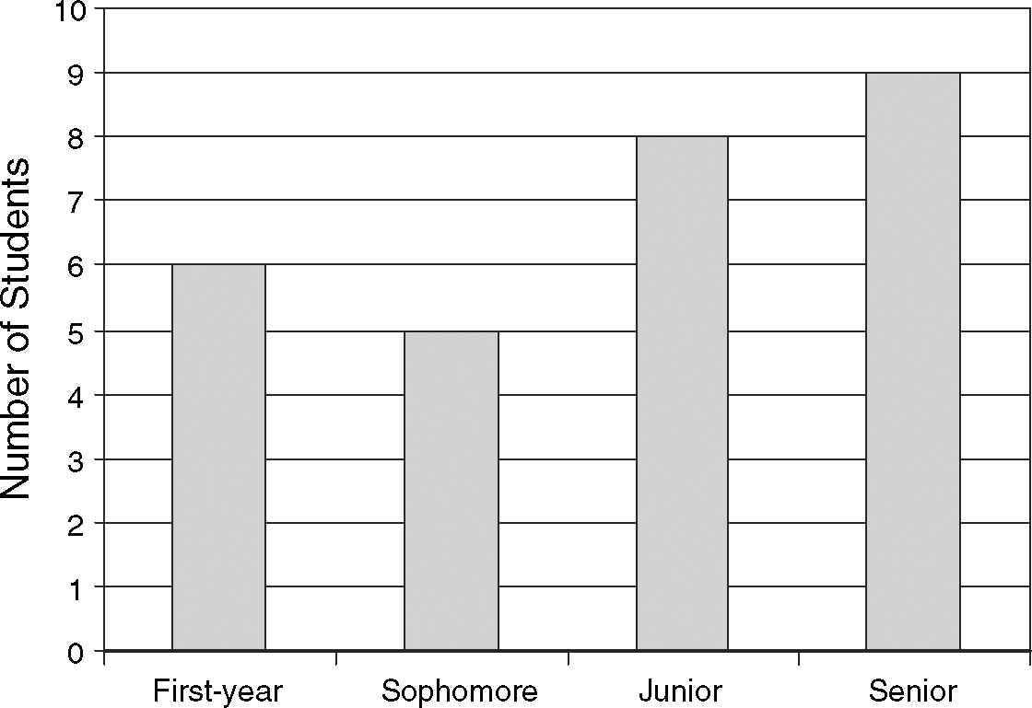
If a student is chosen at random from this group, what is the probability that
the student is a junior or senior?

5. Three number cubes are rolled at the same time. What is the probability that
all three show the same number?

6. What is the probability that a point
chosen inside the rectangle is in
the shaded region?
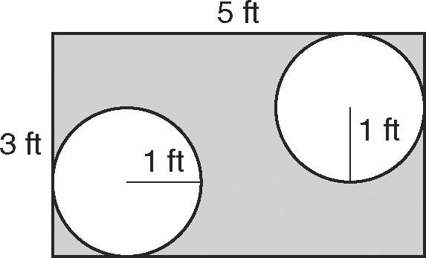

7. Two coins and a number cube are
tossed at the same time. What is the probability that both coins show the
same face and the cube shows a
multiple of 3?

8. A psychologist is studying how children
acquire math skills. She gives the
same question to children at different
ages and records the results.
Math Skills By Age in Years
 | 2 | 3 | 4
Correct | 3 | 6 | 11
Incorrect | 16 | 12 | 5
What is the probability that a child
from this group is 2 or 3 years old
given that they got the question correct?

9. Use the two-way table from Question 8.
What is the approximate probability
that a child got the question correct
given that they are 2?

