Probability Name
Chapter Test Form B

Select the best answer.
1. An English class can choose from 6 books to read this semester. How many different ways can a student choose and read 5 of them?
A 6 C 120
B 36 D 720
2. A menu at a restaurant offers 9 different appetizers. How many different ways can a group order 4 appetizers?
F 81 H 3024
G 126 J 5040
3. A man is redecorating his bedroom. He can choose from 5 paint colors, 6 beds, and 5 dressers. How many ways can he choose to design his room?
A 30 C 150
B 120 D 720
4. A gardener has counted the number of
roses he has of each color. The results
are graphed below.
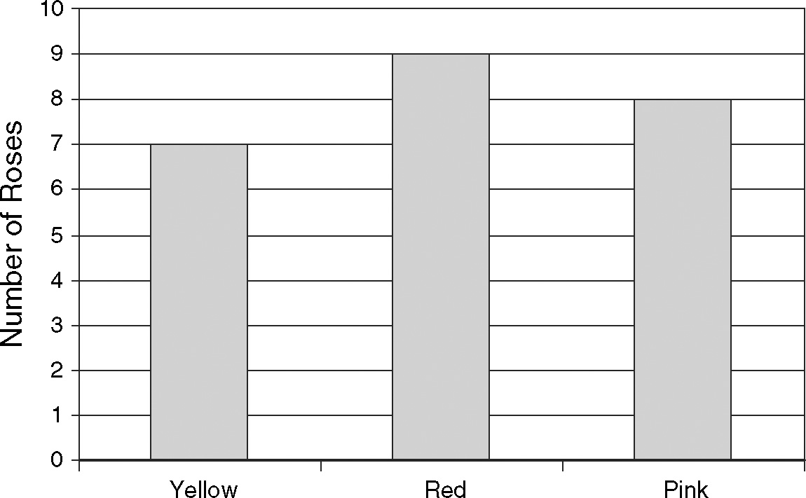
If a rose is picked at random, what is the probability that the rose is pink?
F 0.292 H 0.375
G 0.333 J 0.471
5. Two number cubes are rolled at the
same time. What is the approximate probability that the sum of the two cubes is 2 or 12?
A 0.028 C 0.083
B 0.056 D 0.111
6. What is the approximate probability that
a point chosen inside the rectangle is in
the shaded region?
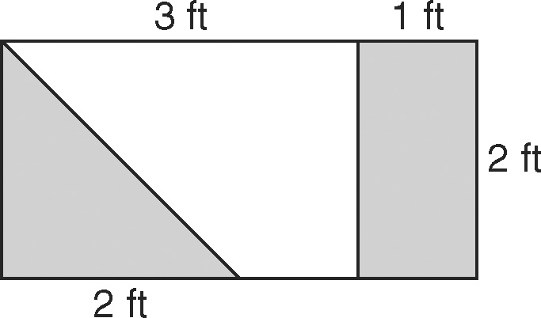
F 0.40 H 0.67
G 0.50 J 0.75
7. Two coins and a number cube are
tossed at the same time. What is the approximate probability that the coins show different sides and the number cube shows a 1 or 6?
A 0.17 C 0.33
B 0.25 D 0.50
8. A company is testing a new method of
manufacturing a part for their machines.
They tested parts using the old and
new methods.
Parts Performance by Age
 | New | Old
Passed | 5 | 23
Failed | 2 | 30
What is the approximate probability
that a part chosen at random from this
group is new and passed the test?
F 0.083 H 0.383
G 0.117 J 0.467
9. Use the two-way table from Question 8.
What is the approximate probability
that a part is old?
A 0.94 C 0.53
B 0.88 D 0.38

