Probability
Chapter Test Form B

1. A movie theater has posters for 7 new movies. How many ways can the theater arrange 5 of the posters on a wall?

2. A customer at a bookstore is interested
in 10 books on sale. How many ways
can she choose 3 books to buy?

3. A man has 4 pairs of dress pants, 4
dress shirts, and 10 ties. How many different ways can he dress for a job interview?

4. In a new neighborhood, houses are constructed of brick, wood, or cement.
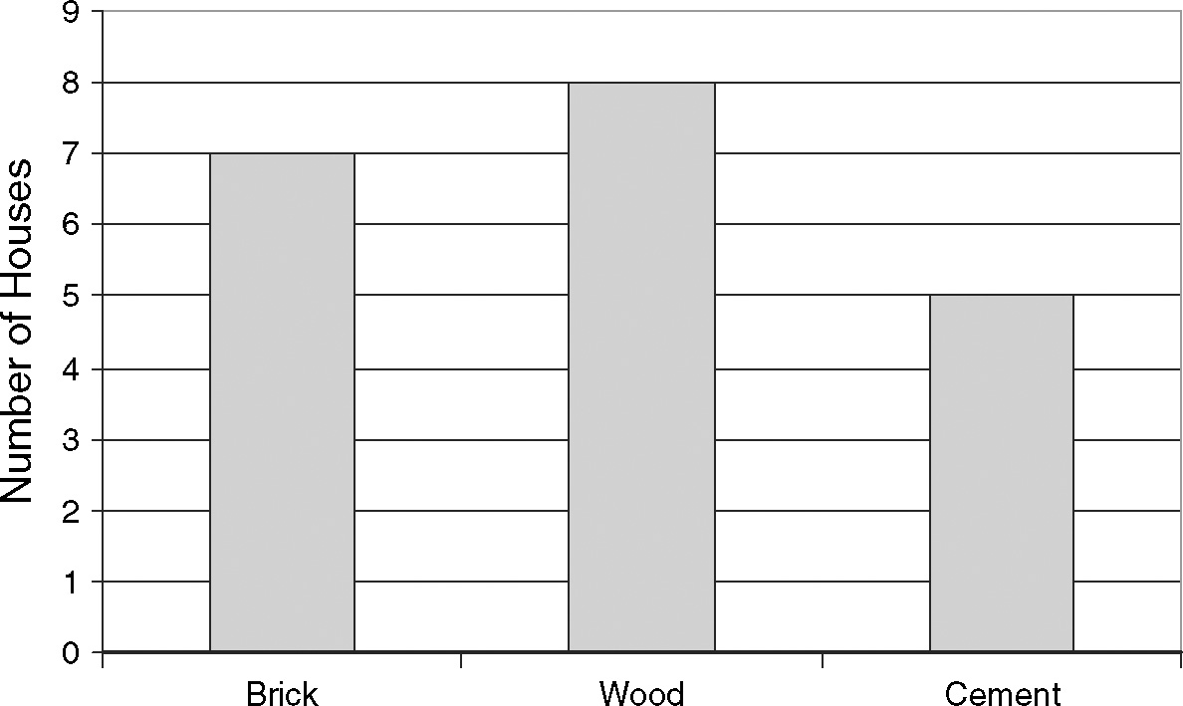
According to the graph above, what is
the probability that a house chosen at random is made of brick?

5. Two number cubes are rolled at the
same time. What is the probability that the two cubes show different numbers?

6. What is the probability that a point
chosen inside the rectangle is in
the shaded region?
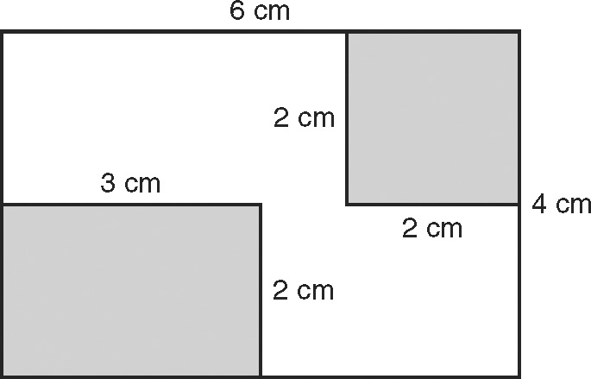

7. A coin and a number cube are tossed at the same time. What is the probability of tossing a tails and rolling a 4 or 5 at the same time?

8. The table shows the results of a consumer survey asking men and
women where they prefer to shop.
Shopping By Gender
 | Male | Female
Store A | 12 | 6
Store B | 4 | 14
What is the probability that a person
chosen from this group is a male who
prefers Store A?

9. Use the two-way table from Question 8.
What is the approximate probability
that a person prefers store A?

