Probability
Chapter Test Form A

1. A child has 4 wooden blocks. How many different ways can she stack 3 of them into a tower?

2. A student is shopping for the first day of school. He chooses 5 shirts that he likes, but can only afford to buy 3 of them.
How many ways can he choose 3 shirts to buy?

3. A restaurant offers 5 appetizers, 6 entrees, and 3 desserts. How many different ways can a customer choose one appetizer, one entrée, and one dessert?

4. The graph below shows the number of students who have traveled to Canada and the number who haven’t.
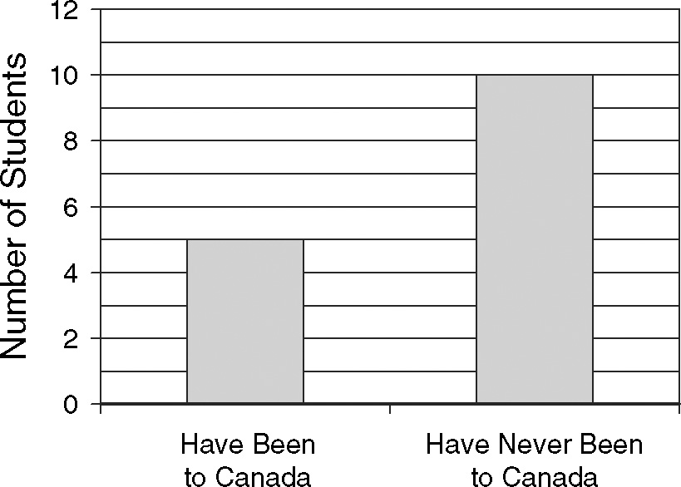
What is the probability that a student chosen at random has been to Canada?

5. If a coin is flipped twice, what is the probability that the result is heads both times?

6. What is the probability that a point
chosen inside the rectangle is in
the shaded region?
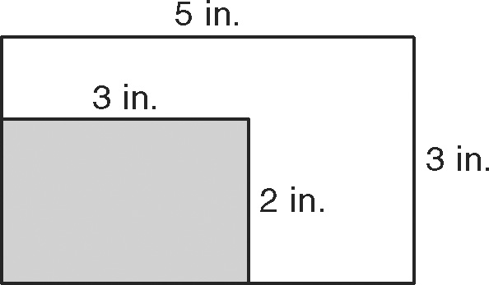

7. If a coin and a number cube are tossed
at the same time, what is the probability of tossing heads and rolling an even number?

8. A television station wants to know how
its newest show is performing. The
results of their poll of high school
students is shown below.
Viewership by Grade
 | 9−10 | 1112
Watch | 8 | 9
Don’t Watch | 7 | 16
What is the probability that a student in
9th or 10th grade watches the show?

9. Use the two-way table from Question 8.
What is the approximate probability
that a student is in 11th or 12th grade?

