Probability
Chapter Test Form C

Select the best answer.
1. An art gallery has 9 paintings to display along a hallway. How many different ways can they choose and display 6 of the paintings?
A 4320 C 60,480
B 40,320 D 362,880
2. A salesman must sell 5 of the 10 new cars in order to reach his quota. In how many ways can he sell 5 of the cars?
F 120 H 30,240
G 252 J 40,320
3. An English teacher has 6 short stories,
4 novels, and 23 poems to choose from. How many ways can he assign one of each to his class?
A 512 C 552
B 529 D 576
4. A bookstore is stocking different
varieties of new books. The number of
each type of book is shown below.
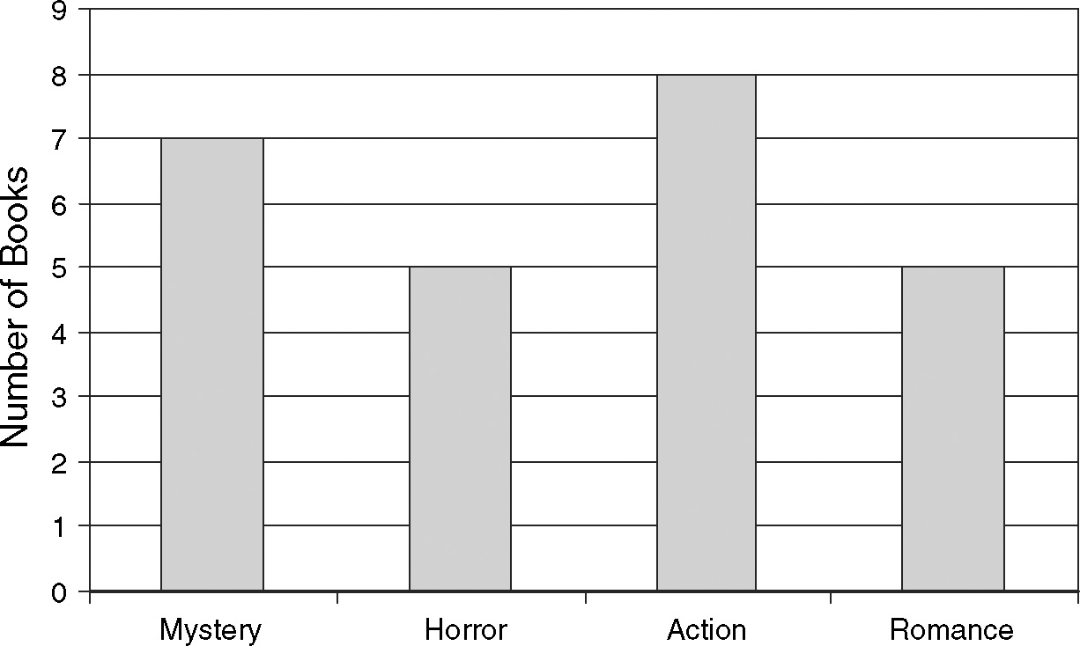
If a book is chosen at random from this group, what is the probability that the book is a horror or action novel?
F 0.20 H 0.48
G 0.38 J 0.52
5. What is the approximate probability that
a point chosen inside the rectangle is in
the shaded region?
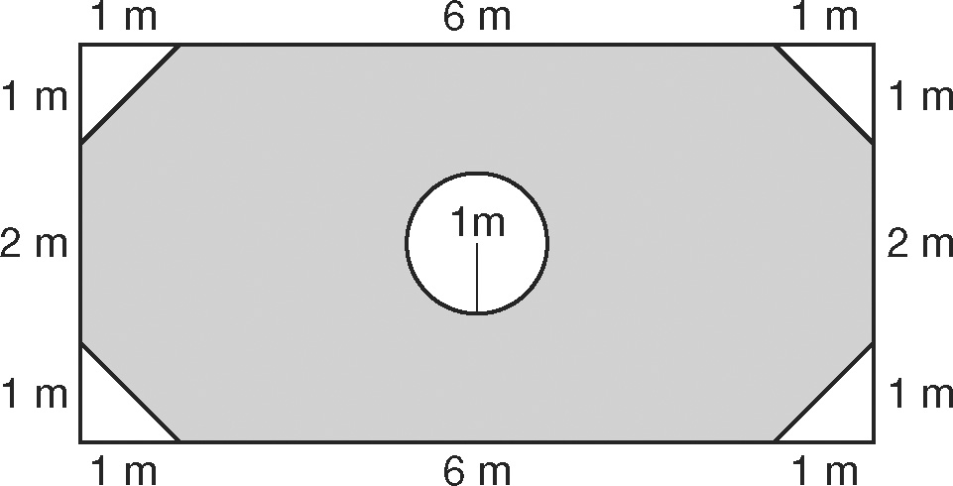
F 0.54 H 0.84
G 0.74 J 0.90
6. Two coins and two number cubes are tossed at the same time. What is the approximate probability that the two
coins show different sides and the two number cubes show the same number?
A 0.04 C 0.17
B 0.08 D 0.33
7. A movie company shows its movies to
a group of viewers before it’s released.
The results of one showing are in the table below.
Approval by Age Group
 | 1834 | 3544 | 4554
Liked | 12 | 5 | 9
Didn’t Like | 3 | 13 | 8
What is the approximate probability
that a person is in the 18−34 age group
given that he or she liked the movie?
F 0.24 H 0.46
G 0.30 J 0.80
8. Use the two-way table from Question 8.
What is the approximate probability
that a person is in the 45-54 age group
given that they liked the movie?
A 1 C 0.35
B 0.52 D 0.18

