Practice A
Piecewise Functions
Create a table for each graph. Then describe the graph in words.
1. a. Use the endpoints and points close to them as the domain values in the table.
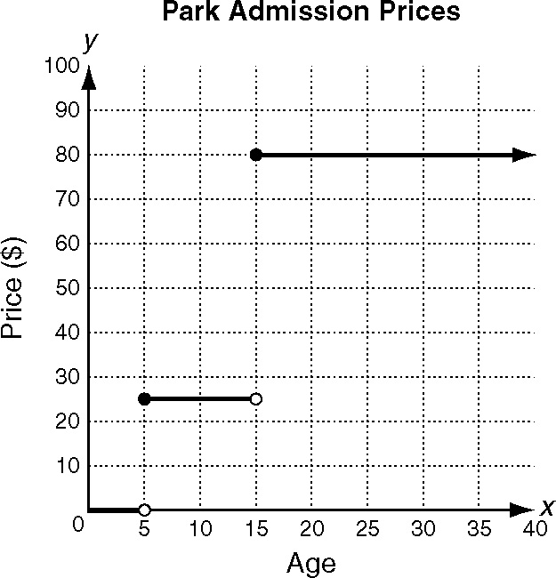
Admission Prices
Age | Price ($)

b. Use the domain intervals and the prices in the table to describe the graph.
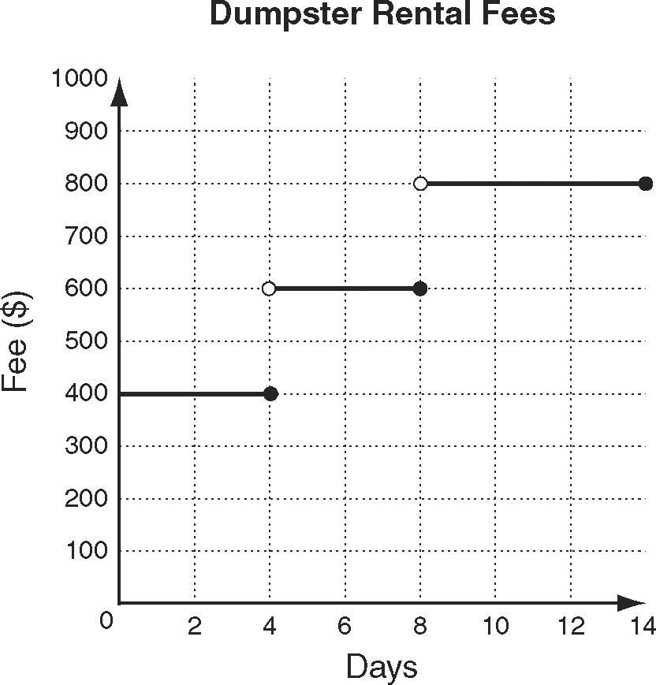
2.
Dumpster Rental Fees
Days | Fee ($)

Evaluate each piecewise function for x = −3 and x = 4.
3. 4.

5. 6.

Reteach
1. For Company A, the initial cost is
$11.00 while the cost for Company B is
$8.00. The hourly rate for company A is
$3.00 while the hourly rate for Company
B is $4.00.
2. As ,
3. As ,

Challenge
1. TAKE AWAY THE S!
2. GEOMETRY
3. DECAGON

Problem Solving
1. D
2. H
3. 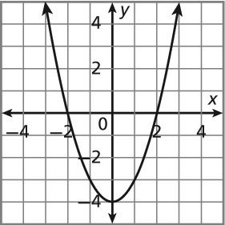 (0, -4)

4. 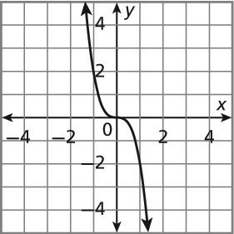 (0, 0)

Reading Strategies
1. As , and as ,
2. As , and as ,
3. As , and as ,
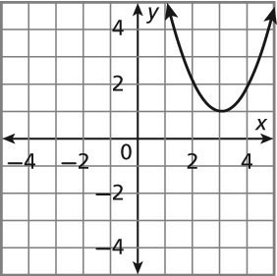
Piecewise Functions

Practice A
1. a.
Admission Prices
Age | Price ($)
Under 5 | Free
5–14 | 25
15 and over | 80
b. Children less than 5 years of age get in free. Children between the ages of 5 and 14 pay $25. Those 15 and over pay $80.
2. a.
Dumpster Rental Fees
Days | Fee ($)
Up to 4 days | 400
More than 4 days and up to 8 days | 600
More than 8 days and up to 14 days | 800
b. A dumpster costs $400 for up to 4 days, $600 for more than 4 days and up to 8 days, and $800 for more than 8 days up to 14 days.
3. 10, −1 4. −10, −3
5. 5, 2 6. −12, 28

