Identifying Exponential Functions
Exponential functions have the variable as an exponent. If we want to identify a function as being exponential we can look at the results of the function and see that the x will be increased by a fixed amount and the results of the function will be increased by a fixed multiple amount.
Linear functions have constant first differences
Quadratics have constant second differences
Exponential functions do not have constant differences but do have constant ratios

For example : f(x) = 2 * 3^{x}

x | y
0 | 2
1 | 6
2 | 18
3 | 54
4 | 162

We can see that we multiple each result by 3, so it is an exponential function
So we can see that our results are growing by a multiple of 3 so it is an exponential function from the data.

x | y
-2 | -5
0 | 5
2 | 10
4 | 30

We are going up by a constant amount and we multiply results by -1, 2, 3 – it is not a constant multiple, so it is not an exponential function.

x | y
2 | 8
3 | 4
4 | 2
5 | 1

For the above data we see that the results are going down by a constant multiple, ½. So it is an exponential function. What is it? Using the calculator and the ExpReg function we get
32*(1/2)^{x}
_______________________________________

x
0 | 40000
1 | 32000
2 | 25600
3 | 20480

When you divide 32000/40000 you get .8
Divide 35600 / 3200 you get .8
So we have a constant ratio which means we have an exponential functiom
Usinr The ExpReg function we get 40000*.8^x

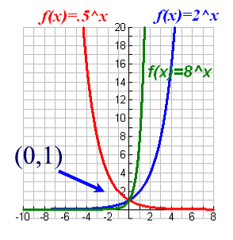 | If the base is greater than 1, as x increases y will go up dramatically. For negative x numbers, y will quickly approach 0.  (2^-4) = 1 / 2^4  If the base is less than 1, the number will quickly approach 0, as x increases.  (1/2)^5 = 1/32  As x is decreases y will increase  (1/2)^-4 = 2^4

Let’s look at
-3 * 2^x

We can see that the negative 3 causes a reflection over the y axis.

