Binomial Expansion

(x + 3)⁴
You know that x will be raised to the 4th as will the 3.

x⁴3⁰ + x³3¹ + x²3² + x¹3³ + x⁰3⁴ = (start with 4th (or 0) power then go down (or up) by 1)

x⁴ + 5x³ + 9x² + 27x¹ + 81 =

we also need to get additional coefficients from Pascal’s triangle

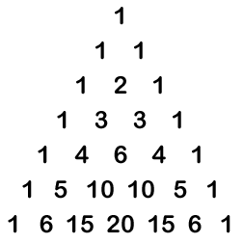 | Go to 5th row for additional coefficients  (1) x⁴ + (4)3x³ + (6)9x² + (4)27x¹ + (1)81 =  x⁴ + 12x³ + 54x² + 108x + 81 =

