Name _______________________________ Quadratic Transformations

The quadratic parent function is **f(x)** **=** **x2**. Its graph is a parabola with its vertex at the origin (0, 0). Describe each transformation from the parent function.

1 g(x) = −x2 2. h(x) = (x − 1)2

3. g(x) = x2 + 7 4.

5. g(x) = (x + 3)2 6. h(x) = 5x2

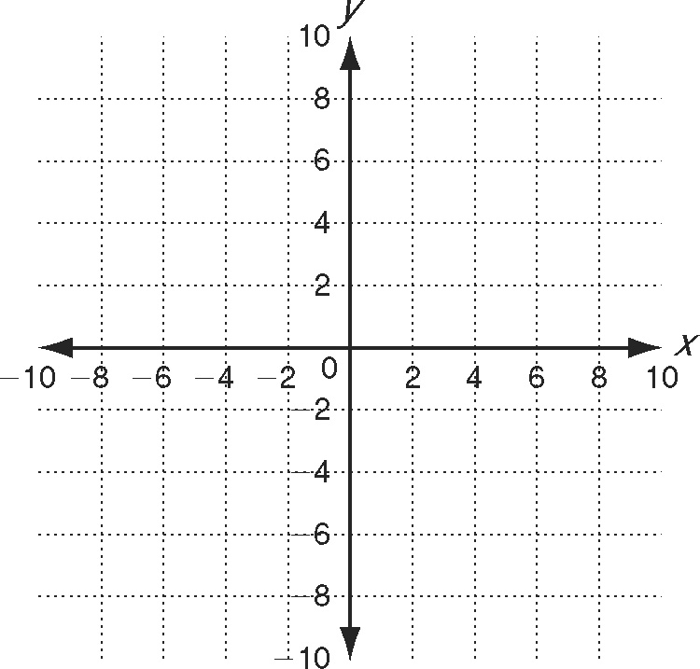The vertex form of a quadratic function   
is **f(x) = a(x − h)2 + k.**

7. a. The parent function f(x) = x2 is translated   
2 units left and 3 units up. Write the quadratic   
function in vertex form.

b. Graph the translated function.

Using the graph of f (x) = x2 as a guide, describe the transformations,   
and then graph each function. Label each function on the graph.

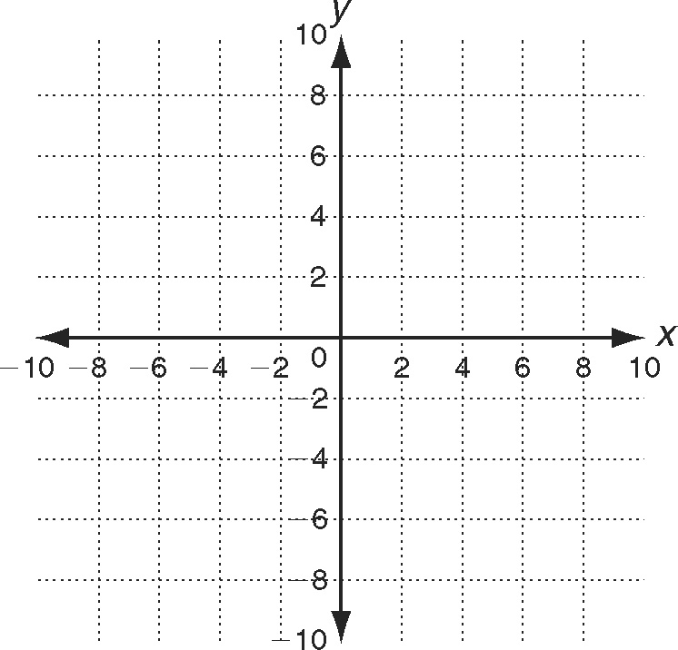 8. h(x) = (x − 2)2 + 2

9 h(x) = −(3x)2

10. 

Use the description to write a quadratic function in vertex form.

11. The parent function f (x) = x2 is reflected across the *x-*axis, horizontally   
stretched by a factor of 3 and translated 2 units down to create function g.

12.. Circle the function that produces the widest parabola.

f(*x*) = 2*x*2 − 4  h(*x*) = 2(*x* − 1)2

13. Transform the function m(*x*) = −3(*x* + 1)2 + 4 so that its vertex is   
located at (0, 0). Write the transformed function.

14. Describe the difference and similarity between these two functions:  
f(*x*) = *x*2 − 1 and f(*x*) = (*x* − 1)2.

The height that a baseball reaches when it is thrown can be modeled by the function h(t) = −16(t − 1.5)2 + 36.

15. What is the shape of the ball’s path?

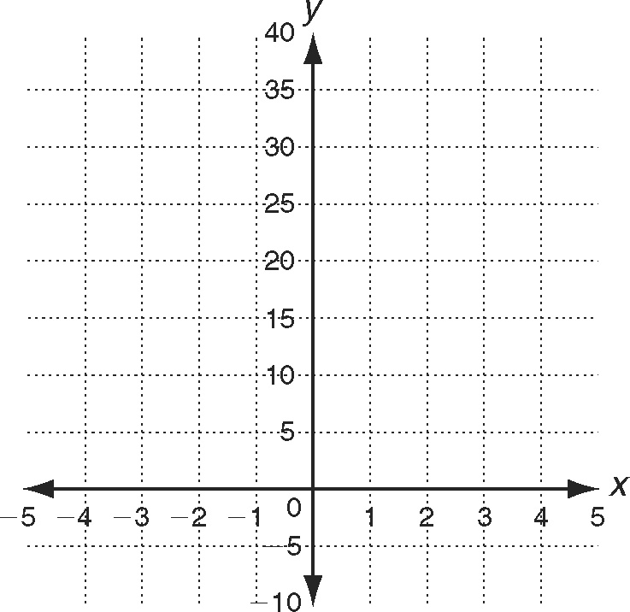 16. What happens to the ball between *t* = 0 and   
*t* = 1.5 seconds?

17. Describe the transformation of *h* from the   
the parent function f(*t*) = *t* 2.

18. Draw a graph of the baseball’s path.