Quadratic Test Name ____________________
For the following functions, (a) determine whether the graph opens upward or downward. Then find (b) the axis of symmetry, (c) the vertex, and (d) the y-intercept. Graph each function. Then (e) determine if the function has a minimum or a maximum and (f) find the value of the minimum or maximum.

1. g(x) = 3x² + 2x + 1 2. f(x) = −2x² − 4x − 2
a. a.
b. b.
c. c.
d. d.
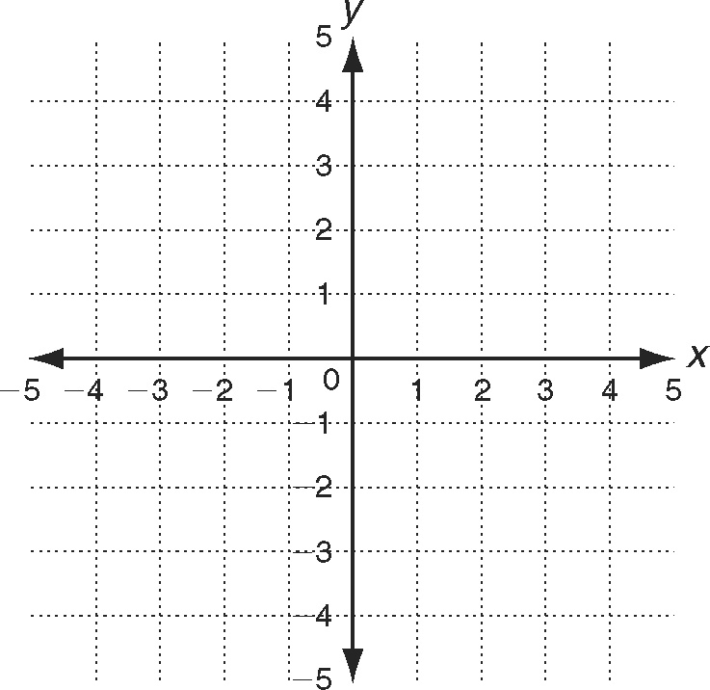
e. e.
f. f.

3. A record label uses the following function to model the sales of a new release.
a(t) = −90t ² + 8100t
The number of albums sold is a function of time, t, in days. On which day
were the most albums sold? What is the maximum number of albums sold
on that day? ________________________________________

4. f(x) = 2(x + 3)² - 4
a. vetex _____________
b. standard form ______________
c. y intercept ______________
graph on right with 2 points

5. f(x) = -(x - 3)² - 2
a. vetex _____________
b. standard form ______________
c. y intercept ______________
graph on right with 2 points

6. f(x) = -2(x – 1)² + 3
a. vetex _____________
b. standard form ______________
c. y intercept ______________
graph on right with 2 points

7. A rocket is shot from a tower 100 feet high. Its path can be modeled with the equation where t is time in seconds and h(t) will be feet.
h(t) = -16t² + 120t + 100
a. What is the vertex? __________
b. When will it reach its height? ___________
c. What will the maximum height be? ___________
d. Graph it to the right

8. f(x) = 3(x +5)² + 7
a. vetex _____________
b. standard form ______________
c. y intercept ______________
graph on right with 2 points

9. f(x) = –2x² + 16 vertex _____________
line of symmetry ____________________

