Name _________________

The quadratic parent function is f(x)  x². Its graph is a parabola with its vertex at the origin (0, 0). Describe each transformation from the parent function.
1. g(x)  x² 2. h(x)  (x  1)²

3. g(x)  x² + 7 4.

5. g(x)  (x  3)² 6. h(x) = 5x²

7. a. The parent function f(x) = x² is translated
2 units left and 3 units up. Write the quadratic
function in vertex form.

Using the graph of f (x) = x² as a guide, describe the transformations,
and then graph each function.

9. h(x) = (x − 2)² + 2 | 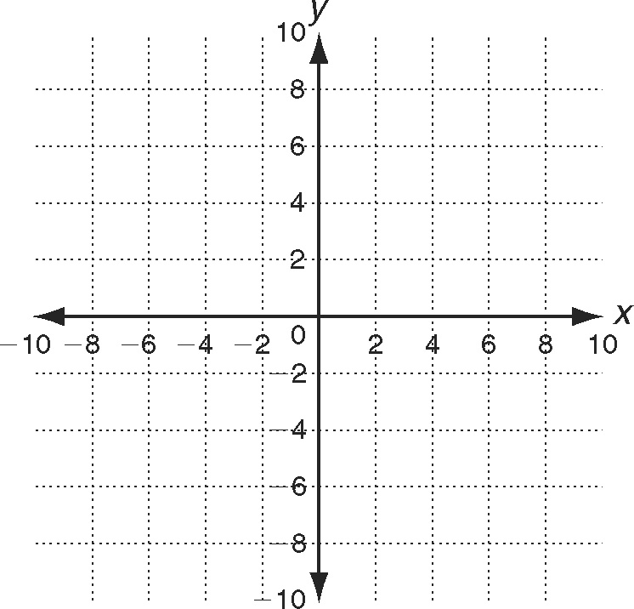

10. h(x) = 2(x + 3)² – 2

11. h(x) = (x - 3)² + 2

12. Given
f(x) = (x + 2)² - 4

Move it 2 to the lright, 2 up

New Equation

Graph it on right

13. Given
f(x) = (x - 2)² + 3

Move it 2 to the left, 2 down

New Equation

Graph it on right

