Challenge
Interpreting the Graphs of Quadratic Functions
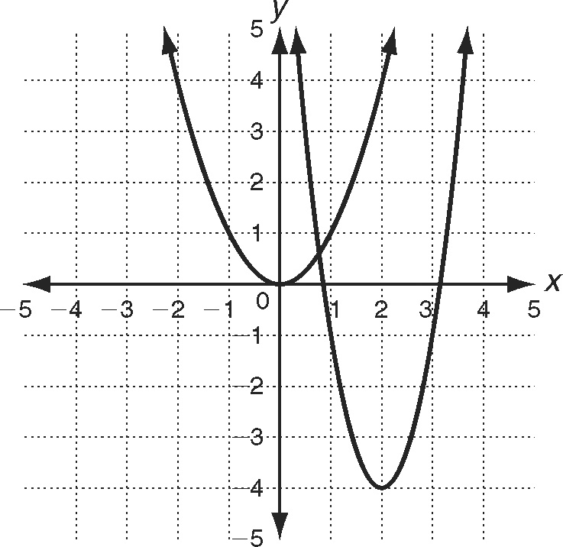
Functions can be translated, reflected, and/or stretched or compressed to make a new function. Consider the two functions below. You recognize one as the graph of y  x². You can write the standard equation of the other function, y  a(x − h)²  k, from the information in the graph.
The parabola opens in the upward or positive
direction. This indicates that a is a positive number.
The vertex has been shifted or translated from the
origin to the point (2, 4), so the values of h and k
are 2 and 4, respectively. Substitute the coordinates
of a point on the graph and solve for a. The resulting
equation is y  3(x − 2)² − 4.
Write the equation for each graph.
1. 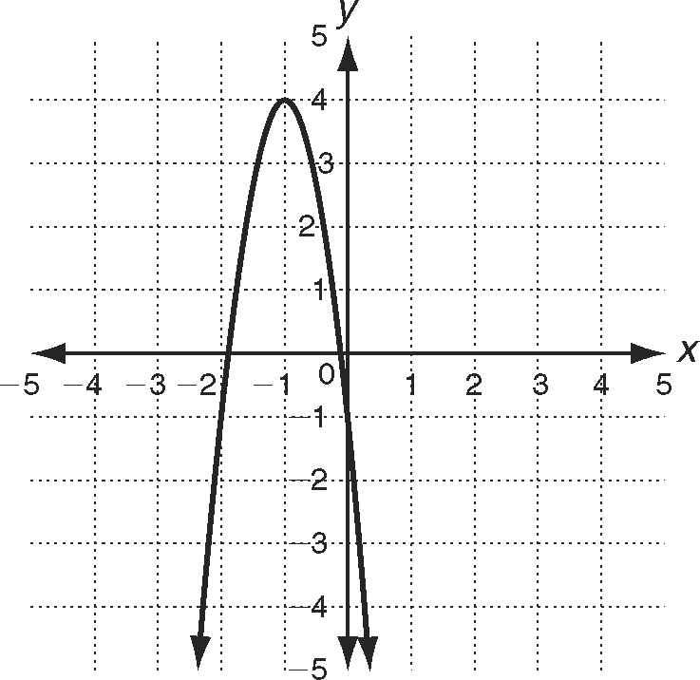 2. 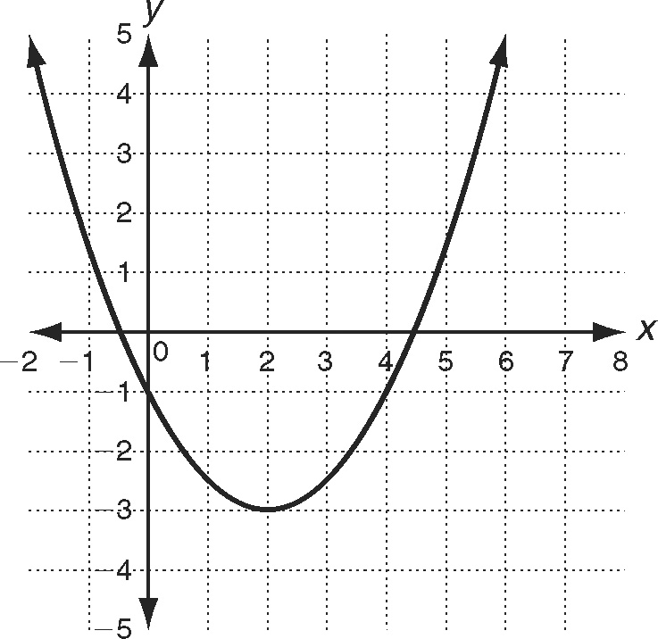

3. 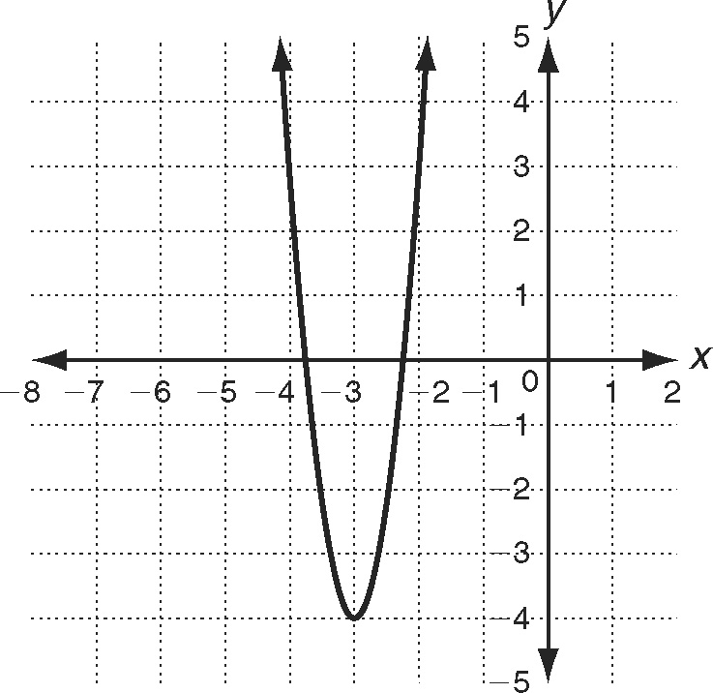 4. 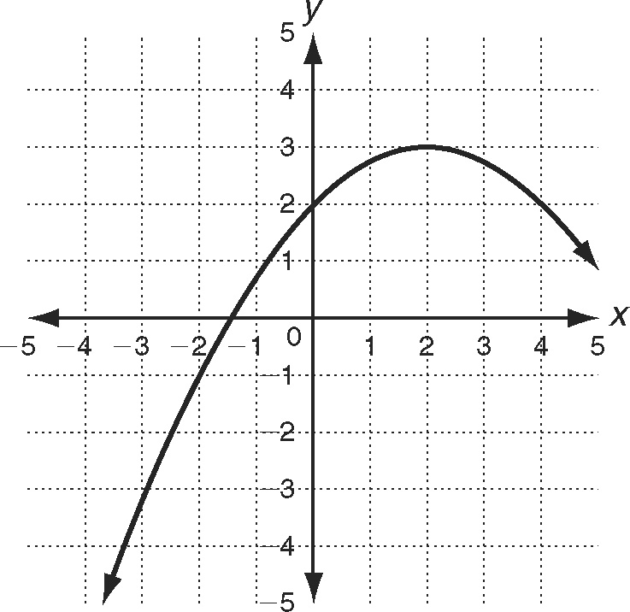

Reteach
1.
x | f(x) = x² − 6x + 7 | (x, f(x))
1 | f(1) = 1² − 6(1) + 7 = 2 | (1, 2)
2 | f(2) = −1 | (2, −1)
3 | f(3) = −2 | (3, −2)
4 | f(4) = −1 | (4, −1)
5 | f(5) = 2 | (5, 2)
2. −3
Graph is shifted 1 unit left and 3 units down.
3. (3, 2)
Graph is shifted 3 units right and 2 units up.

Challenge
1. y = −5(x + 1)² + 4
2. 3. y = 7(x + 3)² − 4
4.

Problem Solving
1.
Time (t) | f(t) = −16t ² + 185 | (t, f(t))
0 | f(0) = −16(0)² + 185 | (0, 185)
1 | f(1) = −16(1)² + 185 | (1, 169)
2 | f(2) = −16(2)² + 185 | (2, 121)
3 | f(3) = −16(3)² + 185 | (3, 41)
4 | f(4) = −16(4)² + 185 | (4, −71)
2. 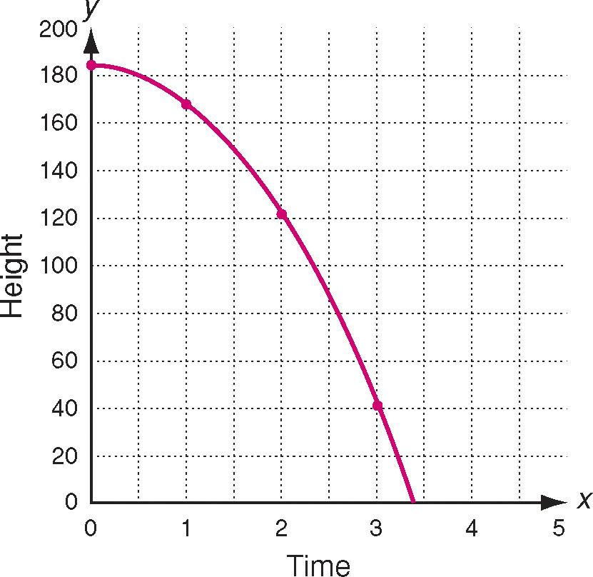
3. f(x) = x² 4. Parabola

5. The graph is translated up 185 units. Since a is negative, it is reflected
across the x-axis. Since |a| = 16, it is stretched vertically by a factor of 16.
6. D 7. B

Reading Strategies
1. a. Line c. Parabola
b. Parabola d. Line
2. Domain = set of all real numbers; range = [3, )
3. ; possible answer: since the slope is positive, the line slopes from the lower left to the upper right.
4. (−6, −3); since a is positive, the parabola opens upward.
Properties of Quadratic Functions in Standard Form

Practice A
1. x = 4 2. x = 2
3. x = −6 4. x = −1
5. True 6. False
7. False
8. a. Upward
b. x =
c.
d. 1 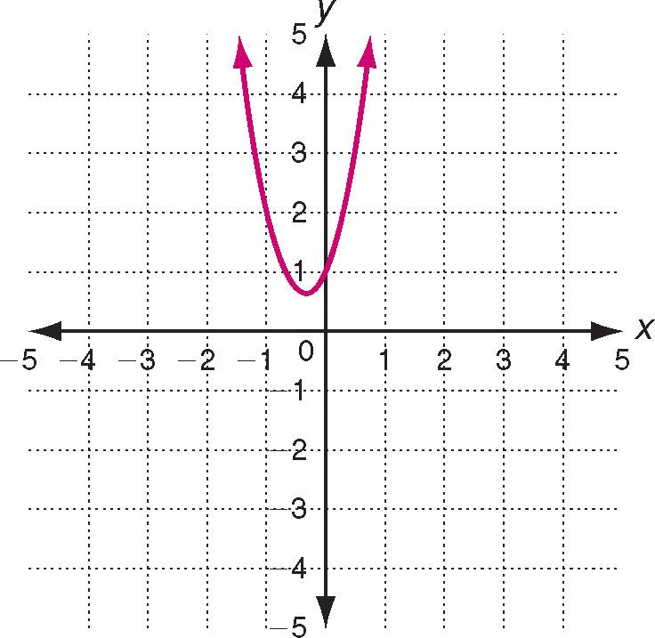
e. Minimum

