Review of Right Triangle Trigonometry
Name:
UNIT 7:Trigonometry I

Do Now:

1. For a given set of rectangles, the length is inversely proportional to the width. In one of these rectangles, the length is 12 and the width is 6. For this set of rectangles, calculate the width of a rectangle whose length is 9.

Notes:

Sin = Cos = Tan =

1. Use the diagram below to answer the evaluate a-f.

a) Sin D b) Cos D c) Tan D

d) Sin F e) Cos F f) Tan F

2. In , , and . Find cosR. | 3. In , , and . Find sinC.
4. Find x to the nearest tenth. | 5. Find x to the nearest tenth.
6. Find x to the nearest degree: | 7. A 10-foot tree is supported in a vertical position by a rope running from the top of the tree to a stake in the ground. If the angle that the rope makes with the ground is 63º, find the length of the supporting rope to the nearest foot.

In # 8 – 15, determine the quadrant in which an angle of the given measure lies.

8. 140º | 9. -430º | 10. 210º | 11. 97º
12. 315º | 13. -168º | 14. -200º | 15. 600º

In #16– 23, draw an angle of the given measure, indicating the direction of the rotation by the arrow. Find the angle coterminal with an angle of the given measure.

16. 100º | 17. -50º | 18. 210º | 19. -300º
20. 470º | 21. -800º | 22. -200º | 23. 60º

24. Which pair of angles are coterminal?

(1) 30º and -30º (2) 150º and -210º (3) 200º and 160º (4) -100º and -80º

Homework on Review of Right Triangle Trigonometry

1. Which ratio represents in the diagram below?
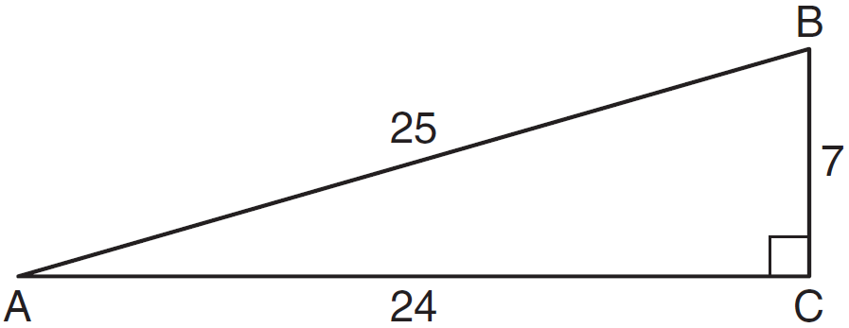
(1) (3)
(2) (4)

2. In the diagram below of right triangle KTW, , , and .
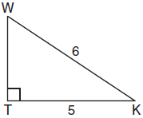

What is the measure of , to the nearest degree?

(1) 33º (2) 34º (3) 35º (4) 36º

3. Which pair of angles are coterminal?

(1) 40º, 140º (2) -30º, -150º (3) 310º, -50º (4) 120º, 240º

In # 4 – 7, determine the quadrant in which the angle terminates.

4. -85º | 5. 468º | 6. -1000º | 7. 219º

8. A ladder 10 feet in length leans against a tree, making an angle of 28º with the ground. How far from the tree was the ladder placed, to the nearest hundredth?

9. Put the equation of the circle in center-radius form. 10. If & ,
Determine the center and radius: find .

The Unit Circle, Signs of the Quadrants, and Quadrantal Angles

Do Now:

The conjugate of is

(1) (2) (3) (4)

Notes:

Signs of the Quadrants Unit Circle:

Center =

Radius =

P (x, y) =

In #1-4, name the quadrants in which an angle of measure could lie when:

1. 2. 3. 4.

In #5 – 10, name the quadrant in which an angle of measure could lie when:

5. 6. 7.

8. 9. 10.

11. If P is a point that lies on the unit circle 12. In the figure, a unit circle is drawn and
and, then find: . Name the line segment whose
length is:
a) a)

b) b)

c) c)

Complete the following table, giving the functional value of each quadrantal angle. If a function is not defined for an angle measure, write “undefined.”

A | $$0^{∘}$$ | $${\text{90}}^{∘}$$ | $${\text{180}}^{∘}$$ | $${\text{270}}^{∘}$$ | $${\text{360}}^{∘}$$
Sin A
Cos A
Tan A

In #13 - 18, find the exact numerical value of the expressions given below.

13. 14. $(\text{cos}0^{∘})^{2}+\text{tan}{\text{180}}^{∘}$ 15. $\frac{\text{tan}{\text{180}}^{∘}}{\text{sin}{\text{90}}^{∘}}$

16. $\text{sin}{\text{90}}^{∘}+\text{cos}0^{∘}$ 17. $\text{cos}{\text{180}}^{∘}+\text{sin}{\text{270}}^{∘}$ 18.

HW on Unit Circle, Signs of Quadrants, Quadrantal Angles

1. If is negative and is negative, in which quadrant does the terminal side of lie?

(1) I (2) II (3) III (4) IV

2. If and , in which quadrant does terminate?

(1) I (2) II (3) III (4) IV

3. If 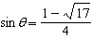, then angle lies in which quadrants?

(1) I and II (2) II and III (3) I and III (4) III and IV

4. If 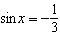 and , in which quadrant does angle x lie?

(1) I (2) II (3) III (4) IV

5. If , in which quadrants may angle terminate?

(1) I and II (2) II and III (3) I and III (4) III and IV

6. If 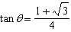, then angle may terminate in Quadrant

(1) I and II (2) II and III (3) I and III (4) III and IV

7. If lies on the terminal side of of a unit circle, find:

a) the quadrant terminates in b) the value of

c) the value of d) the value of

8. An angle whose measure is -214º is coterminal with all of the following except

(1) -574º (2) 34º (3) 146º (4) 506º

9. If is an angle in standard position and is a point on the unit circle on the terminal side of , what is the value of ?

(1) (2) (3) (4)

10. Find the solution set to the inequality and graph it on the number line below:

11. Solve for x and express your answer in simplest radical form:

Special Angles of 30º, 60º, and 45º

Do Now:

1. If , in which quadrants can terminate? 2. Simplify:

Notes:

Fill in the table below:

$$θ$$ | 30º | 45º | 60º
Sin$θ$
Cos$θ$
Tan$θ$

Find the exact numerical value of the expression.

1. $\text{sin}{\text{30}}^{∘}+\text{cos}{\text{60}}^{∘}$ | 2. $(\text{sin}{\text{60}}^{∘})(\text{cos}{\text{60}}^{∘})$ | 3. $(\text{tan}{\text{60}}^{∘})^{2}$ | 4. $\text{sin}{\text{45}}^{∘}+\text{cos}{\text{45}}^{∘}$
5. $\text{cos}{\text{60}}^{0}(\text{cos}0^{0}−\text{cos}{\text{180}}^{0})$ | 6. | 7. | 8. $\text{tan}{\text{45}}^{∘}+2\text{cos}{\text{60}}^{∘}$
9. $(\text{cos}{\text{45}}^{∘})^{2}$ | 10. $(\text{tan}{\text{60}}^{∘})(\text{tan}{\text{30}}^{∘})$ | 11. $(\text{cos}{\text{60}}^{∘}+2\text{tan}{\text{45}}^{∘})^{2}$ | 12. $(\text{tan}{\text{60}}^{0})^{2}+\text{sin}{\text{180}}^{0}$

13. If $θ$ is the measure of an acute angle and $\text{sin}θ=\frac{\sqrt{3}}{2}$, then:
(1) $\text{cos}θ=\frac{\sqrt{3}}{2}$ (2) $\text{tan}θ=1$ (3) $\text{cos}θ=\frac{1}{2}$ (4)$\text{tan}θ=\frac{\sqrt{3}}{3}$

14. If $φ={\text{30}}^{∘}$, which expression has the largest numerical value?

(1) $\text{sin}φ$ (2) $\text{cos}φ$ (3) $\text{tan}φ$ (4) $(\text{cos}φ)(\text{tan}φ)$

15. If $\text{sin}θ=\sqrt{3}\text{cos}θ$, then $θ$ can equal:

(1) $0^{∘}$ (2) ${\text{30}}^{∘}$ (3) ${\text{45}}^{∘}$ (4) ${\text{60}}^{∘}$

Special Angles Homework

In #1 – 6, find the exact value of each expression:

1. tan 30º + cos 60º | 2. (tan 45º)(cos 45º) | 3. cos 60º + sin 30º - tan 45º
4. sin² 45º • cos 45º | 5. (cos 60º)² +(sin 30º)² | 6. $(\text{sin}0^{0})(\text{tan}{\text{30}}^{0})+\text{cos}0^{0}$

7. If and , what might be the measure of ?

(1) 81º (2) 128º (3) 207º (4) 313º

8. Which of the following is a false statement?

(1) Tan is undefined whenever cos equals zero.
(2) Tan equals zero whenever sin equals zero.
(3) Sin can equal cos in Quadrant I or Quadrant III of the unit circle.
(4) Sin can equal cos only in Quadrant I of the unit circle.

9. If, then $θ$can equal

(1) 0${}^{0}$ (2) 30${}^{0}$ (3) 45${}^{0}$ (4) 60${}^{0}$

10. The value of $2(\text{sin}{\text{30}}^{0})(\text{cos}{\text{30}}^{0})$is equal to the value of

(1) sin 60${}^{0}$ (2) cos 60${}^{0}$ (3) sin 90${}^{0}$ (4) tan 30${}^{0}$

11. Simplify: 12. Solve for x:

Reference Angles

Do Now:

1. Which angle is coterminal to -400º?

(1) 40º (2) -40º (3) 140º (4) -220º

Notes:
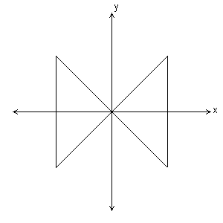
- What is a reference angle??

In #1-8 write the reference angle for each given angle.

1. 100º 2. 340º 3. 248º 4. 98º

5. 200º 6. 7. 745º 8.

In 9 – 16, express the given function as a function of a positive acute angle.

9. 10. 11. 12.

13. 14. 15. 16.

In 17 – 20, find the exact function value.

17. 18. 19. 20.
HW on Reference Angles

In # 1 – 4, find the EXACT value:

1. 2. 3. 4.

In # 5 – 8, express each function as a function with a positive acute angle.

5. 6. 7. 8.

9. If lies on the terminal side of on a unit circle, what can be?

(1) 60º (2) 120º (3) 210º (4) 240º

10. What is the reference angle for -132º?

(1) -48º (2) 48º (3) 228º (4) -228º

11. If , evaluate:

a) b)

12. Is r directly or inversely proportional to s? 13. If and , find and
Find x. graph . Evaluate
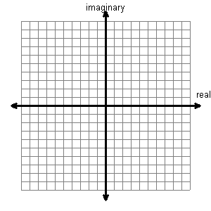
r | 4 | 12 | x
s | 6 | 2 | 3

Converting to and from Radian Measure!!

Do Now:

1. For the angle -500º, find: 2. Given the diagram below, circle O is a
unit circle. Find the line segment that
a) the reference angle b) an angle co-terminal to it represents:

a)

b)

c)

CONVERTING:

In 1-8, convert each degree measure radian measure in terms of .

1. 2. 3. 4.

5. 6. 7. 8.

In 9 – 16, find the degree measure of an angle of the given radian measure.

9. 10. 11. 12.

13. 14. 15. 2.35 radians 16. 3.14 radians

HW on Converting to and from Radian Measure!!

In #1 – 5, convert the following angles to radian measure.

1. | 2. | 3. | 4. | 5.

In #6 – 10, convert the following angles to degree measure.

6. | 7. | 8. | 9. | 10.

11. Convert 5.21 radians to degrees. Round your answer to the nearest thousandth.

12. What is the domain of ?

(1) (2) (3) (4)

13. If one of the roots to the equation is 3, find k.

(1) 1 (2) -1 (3) -2 (4) 5

14. If and , find the value of .

15. What type of roots will the equation have?

(1) real, rational, and equal (3) real and irrational
(2) real, rational, and unequal (4) imaginary

16. Solve for x by completing the square. Place your answer in simplest radical form.

Evaluating Trigonometric Functions!!

Do Now

1. If lies on the terminal side of on the unit circle, find:

a) b) c)

2. Simplify: 3. Simplify and express with positive exponents:

Evaluating in Radians and Degrees!

In 1-8, find the exact value of the trigonometric function.
s
1. 2. 3. 4.

5. 6. 7. 8.

9. If a function f is defined as find the numerical value of:

a) b) c) d)

In 10 – 12, find the numerical value of for the given function f.

10. 11. 12.
HW on Evaluating Trigonometric Functions in Radians and Degrees!

In #1 – 4, find the exact value of each.
1. 2. 3. 4.

In 5-7, find the numerical value of for the given function f.

5. 6. 7.

8. An angle whose measure is $\frac{π}{3}$ has the same terminal side as an angle whose measure is
(1) (2) (3) (4)

9. Which expression is undefined?

(1) sin $\frac{π}{2}$ (2) cos $\frac{π}{2}$ (3) tan $\frac{π}{2}$ (4) tan$\frac{π}{4}$

10. If sin x > 0 and cos x < 0, x must be the measure of an angle in Quadrant

(1) I or II (2) II or IV (3) I or IV (4) II or III

In #11-13, write each expression as a function of a positive acute angle (reference angle).

11. sin138${}^{o}$ 12. cos490${}^{o}$ 13.

14. Brianna lets out 300 feet of string while she is flying her kite. Assuming that the string is stretched taut and makes an angle of $\text{48}°$ with the ground, find to the nearest foot the height of the kite above the ground.

