Name___________________________________

Sine, Cosine, and Tangent Practice

Find the value of each trigonometric ratio. Express your answer as a fraction in lowest terms.

1) sin C 2) sin C

 |  | A
 | 29 | 21
C | 20 | B
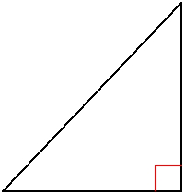

3) cos C

 |  | A
 | 39 | 15
C | 36 | B
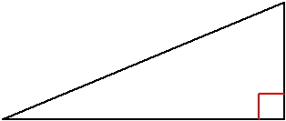

 |  | A
 | 50 | 30
C | 40 | B
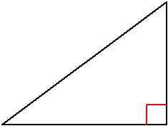

4) | cos C
 |  |  | A
 |  | 17 | 15
 | C | 8 | B
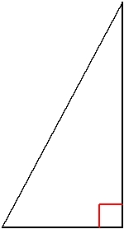

5) tan A

 |  | C
 | 37 | 12
A | 35 | B
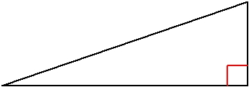

6) tan X

 |  | Z
 | 45 | 36
X | 27 | Y
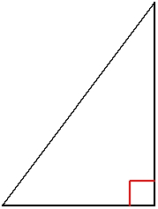

-1-

Find the value of each trigonometric ratio to the nearest ten-thousandth.

7) sin 62° 8) sin 14°

9) cos 60° 10) cos 31°

11) tan 79° 12) tan 25°

Find the missing side. |  |  |  | Round to the nearest tenth.
13) |  | x |  | 14)
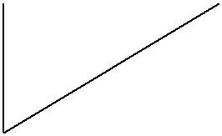

x
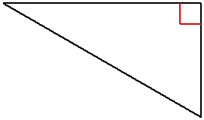

59° | 17 | 17 | 60°

15) |  | 16)
 | 20 | x
 | 20 | 51°
 | 27° | 10
 | x | 10
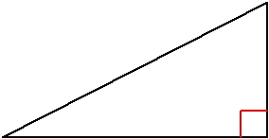
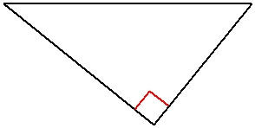

17) | x | 18)
 | x | x | 12
 | 40° | x | 12
 | 40° |  | 53°
 | 20 |  | 53°
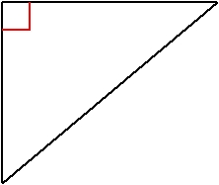
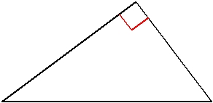

-2-

Find the measure of the indicated angle to the nearest degree.

19) |  | 44 | 20)
 |  | 44 | 26
 | ? |  | 26
 |  | 39 | ?
 |  | 39 | 33
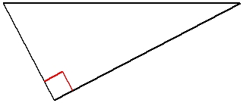
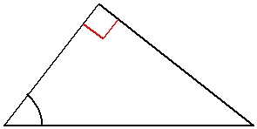

21) | 24 |  | 22)
 | 24 |  | 20
 | ?
 | ? |  | ?
 | 36 |  |  | 23
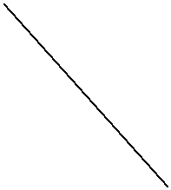
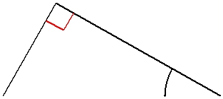

23) | 33 | 24) | ?
10 | 33 |  | ?
10 | ?
 | ? | 13 | 16
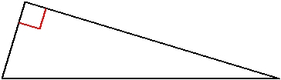
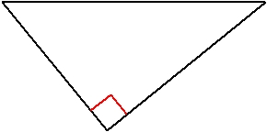

Find each angle measure to the nearest degree.

25) sin X = 0.7547 26) sin A = 0.4540

27) cos Y = 0.5736 28) cos B = 0.5000

29) tan B = 0.6249 30) tan C = 0.1405

-3-

Solve the following word problems. For each question, draw a diagram to help you.

- An airplane is flying at an altitude of 6000 m over the ocean directly toward a coastline. At a certain time, the angle of depression to the coastline from the airplane is 14°. How much farther (to the nearest kilometer) does the airplane have to fly before it is directly above the coastline?

- From a horizontal distance of 80.0 m, the angle of elevation to the top of a flagpole is 18°. Calculate the height of the flagpole to the nearest tenth of a metre.

- A 9.0 m ladder rests against the side of a wall. The bottom of the ladder is 1.5 m from the base of the wall. Determine the measure of the angle between the ladder and the ground, to the nearest degree.

- The angle of elevation of the sun is 68° when a tree casts a shadow 14.3 m long. How tall is the tree, to the nearest tenth of a metre?

- A wheelchair ramp is 4.2 m long. It rises 0.7 m. What is its angle of inclination to the nearest degree?

- A person flying a kite has released 176 m of string. The string makes an angle of 27° with the ground. How high is the kite? How far away is the kite horizontally? Answer to the nearest metre.

-4-

 |  |  | Answers to Sine, Cosine, and Tangent Practice (ID: 1)
1) | 21 |  | 2) | 3 |  | 3) | 12
1) | 29 |  | 2) | 5 |  | 3) | 13
4) | 8 |  | 5) | 12 |  | 6) | 4
4) | 17 |  | 5) | 35 |  | 6) | 3
7) | 0.8829 |  | 8) | 0.2419 |  | 9) | 0.5000
10) | 0.8572 |  | 11) | 5.1446 |  | 12) | 0.4663
13) | 14.6 |  | 14) | 14.7 |  | 15) | 17.8
16) | 15.9 |  | 17) | 23.8 |  | 18) | 15.9
19) | 62° |  | 20) | 52° |  | 21) | 48°
22) | 30° |  | 23) | 17° |  | 24) | 39°
25) | 49° |  | 26) | 27° |  | 27) | 55°
28) | 60° |  | 29) | 32° |  | 30) | 8°
31) | 24 km |  | 32) | 26.0 m |  | 33) | 80°
34) | 35.4 m |  | 35) | 10° |  | 36) | 80 m high, 157 m away

