Practice C
Right-Angle Trigonometry
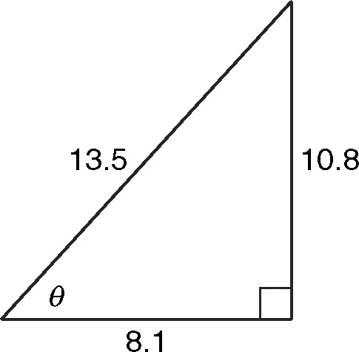
Find the value of the sine, cosine, and tangent functions for θ.
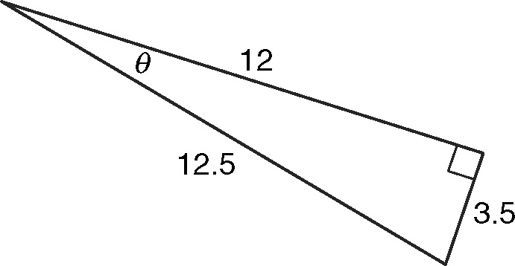
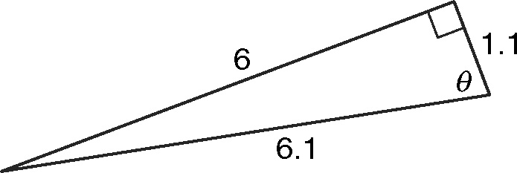
1. 2. 3.

Use a trigonometric function to find the value of x.
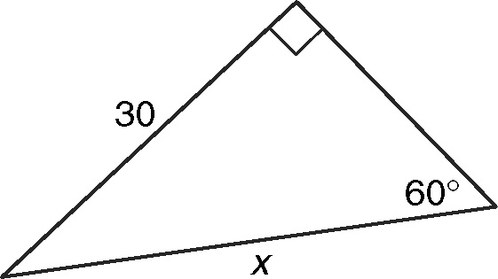
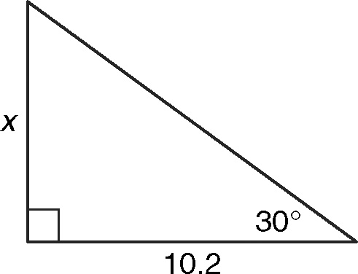
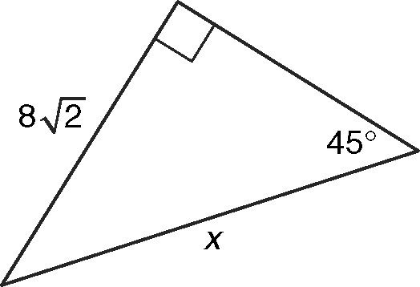
4. 5. 6.

Find the values of the six trigonometric functions for θ.
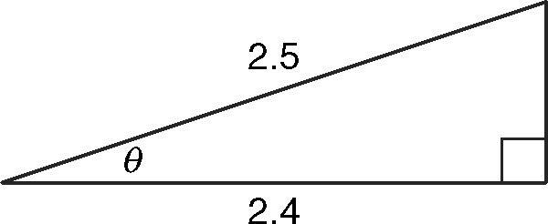
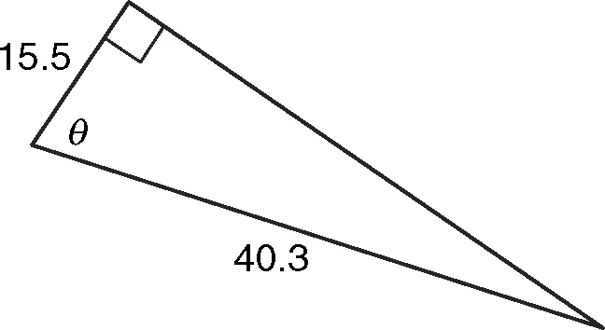
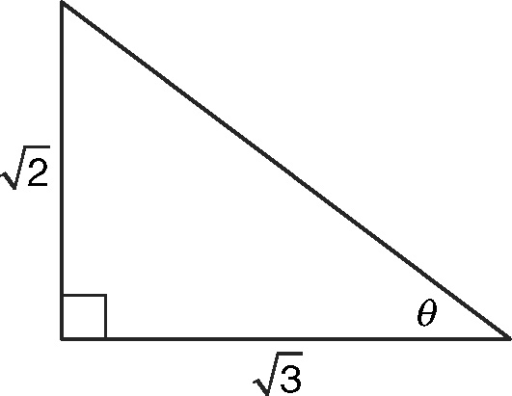
7. 8. 9.

Solve.
10. A kite string is 102 feet long. The angle between the
kite string and the ground is 54.9°. How high is the kite?
11. A surveyor stands 186 feet from the base of a cliff and
measures the angle of elevation to be 56.6°. His eye level
is 5 feet above the ground. What is the height of the cliff
to the nearest foot?
12. The pilot of a hot air balloon measures the angle of
depression to a landing spot to be 36.7°. If the pilot’s
altitude is 1752 meters, what is the horizontal distance
to the landing spot to the nearest meter?
Right-Angle Trigonometry

Practice A
1. a.
b.
c.
2. 3.
4.
5. a. Cosine
b. cos 45 =
c. cos 45 =
d. x = 12
6. 10 7. 8
8. 9 9. 45 ft

Practice B
1. 2.
3. 4.
5. 6. 7
7.
8.
9.
10. 47 ft 11. 162 ft
12. 4817 m

Practice C
1. 2.
3. 4.
5. 6. 16
7.
8.
9.
10. 83.5 ft 11. 287 ft
12. 2350 m

Reteach
1.
2.
3.

