Practice A
Right-Angle Trigonometry
Find the value of the sine, cosine, and tangent functions for θ.
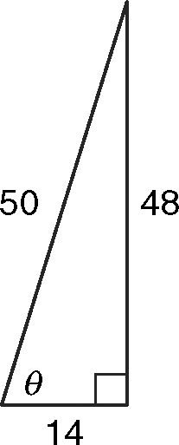
1. Write and simplify the fractions.
a.
b.
c.
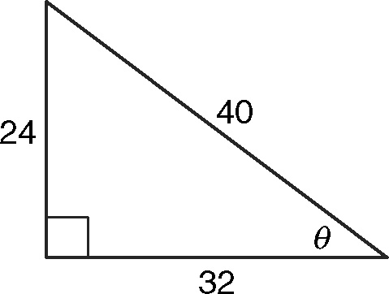
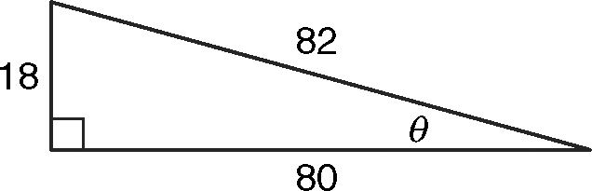
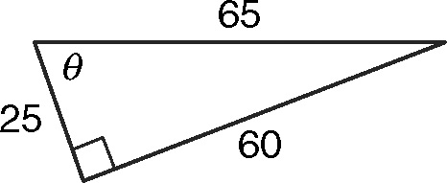
2. 3. 4.

Use a trigonometric function to find the value of x.
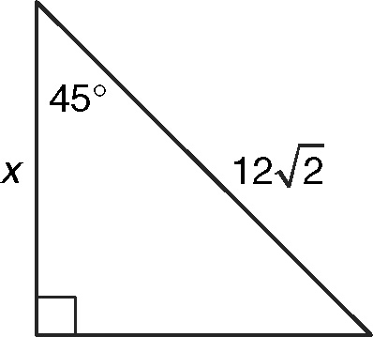
5.
a. Choose the function.
b. Substitute given values.
c. Evaluate the trigonometric
ratio for the angle measure.
d. Solve the proportion for x.
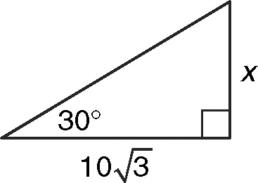
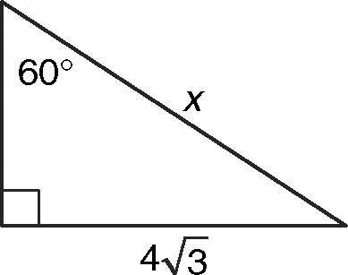
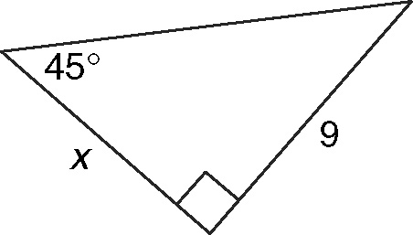
6. 7. 8.

Solve.
9. A conveyor belt leads from the ground to a barn door 24 feet high.
The angle between the belt and the ground is 32°. What is the
length of the conveyor belt to the nearest foot?
Right-Angle Trigonometry

Practice A
1. a.
b.
c.
2. 3.
4.
5. a. Cosine
b. cos 45 =
c. cos 45 =
d. x = 12
6. 10 7. 8
8. 9 9. 45 ft

Practice B
1. 2.
3. 4.
5. 6. 7
7.
8.
9.
10. 47 ft 11. 162 ft
12. 4817 m

Practice C
1. 2.
3. 4.
5. 6. 16
7.
8.
9.
10. 83.5 ft 11. 287 ft
12. 2350 m

Reteach
1.
2.
3.

