Name - _________________________ Block - ______ Precalculus

Section 4.2 Worksheet

Identify one positive and one negative coterminal angle.
1. 2.

3. State the angle measure represented by 2.4 rotations clockwise.

4. Identify all coterminal angles between and for .

5. A angle is in standard position. Determine a) a coterminal angle that is ; b) state the quadrant in which the terminal side lies

6. A angle is in standard position. Determine a) a coterminal angle that is ; b) state the quadrant in which the terminal side lies

7. Identify all the angles that are coterminal with an angle. Then list one positive angle and one negative angle that are coterminal to that angle as well.

8. Identify all the angles that are coterminal with an angle. Then list one positive angle and one negative angle that are coterminal to that angle as well.

9. Find m if . Round to the nearest tenth.
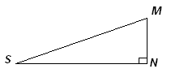

10. A tree casts a shadow 51 feet long when the angle of elevation of the sun (measured with the horizon) is 25°. How tall is the tree?

Change each degree measure to radian measure in terms of .
11. 12. 13.

14. 15. 16.

17. 18. 19.

Change each radian measure to degree measure. Round to the nearest tenth, if necessary.
20. 21. 22.

23. 24. 25.

26. 27. 28.

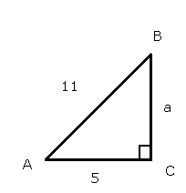
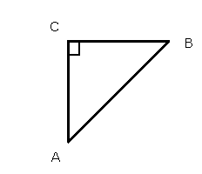
29. Find the value for the six trigonometric ratios for . 30. Solve the triangle. Round to the nearest tenth.

