Coterminal Angles
Two angles in standard position that share a common terminal side are said to be coterminal.

For example the angle 50º is coterminal to the angle 410º
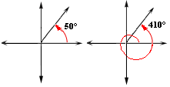
A 50º angle would also be coterminal to a -310º angle.
___________________________________________________________________________
Below we see an angle that is 30º. it would be coterminal with a -330º angle. It would also be coterminal to a 390º angle.
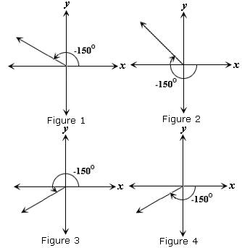 | Name 2 angles coterminal to the angles on the left.  1. Figure 1  _____________ ______________  2. Figure 2  _____________ ______________  3. Figure 3  _____________ ______________  4. Figure 4  _____________ ______________

