Translating Test
Name _______________________

1. f(x) = 2x - 3  Translate graph 3 to the left  Write it in terms of g(x) and then graph both on right | 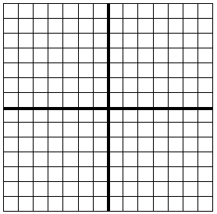

2. f(x) = -4x - 4

Translate graph 2 up and then 2 to the right
Write it in terms of g(x) and then graph both on right

3. f(x) = 2x + 1

Translate graph 4 up then reflect it over x axis
Write it in terms of g(x) and then graph both on right

4. f(x) = -5x + 5

Translate graph 3 to left

Write it in terms of g(x) and then graph both on right

5. f(x) = 3x - 4

Reflect it over the x axis then translate 2 to the right

Write it in terms of g(x) and then graph both on right

6. f(x) = 2x – 3

Reflect over x axis and then translate two to the left

Write it in terms of g(x) and then graph both on right

7 f(x) = 8x + 3

Translate two to the right and then reflect over y axis

Write it in terms of g(x) and then graph both on right

8. f(x) = 1/2x + 5

Translate graph 3 down then 2 to the right

9. f(x) = 6x - 4

Move it 3 up then 3 to the left

10. f(x) = 4x - 6

Move it 3 right then reflect it over the x axis

11. f(x) = x + 6

Move it 3 left

12. f(x) = -4x + 4

Reflect over y axis

