Translating 2
Name _______________________

1. f(x) = x - 3  Translate graph 3 to the left then reflect it over the y axis.  Write it in terms of g(x) and then graph both on right | 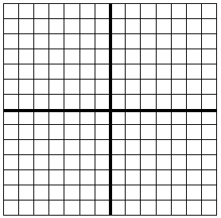

2. f(x) = -5x + 6

Translate graph 3 down then 2 to the right

3. f(x) = -2x - 3

Translate graph 2 to the right and then reflect it over the y axis

4. f(x) = -4x - 2

Reflect it over the y axis and then move it 4 up

5. f(x) = 6x

Move it 3 up then 2 to the left

6. f(x) = -4x + 1

Move it 3 right

7. f(x) = x - 6

Move it 3 left then 2 up

8. f(x) = 4x + 4

Reflect over y axis then move down 2

