Translating
Name _______________________

1. f(x) = x + 3  Translate graph 3 to the left  Write it in terms of g(x) and then graph both on right | 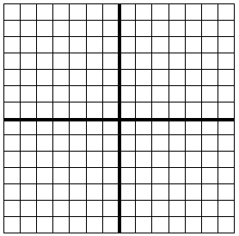

2. f(x) = -2x – 6

Translate graph 3 down

Write it in terms of g(x) and then graph both on right

3. f(x) = 4x + 4

Translate graph 2 up and then 2 to the right
Write it in terms of g(x) and then graph both on right

4. f(x) = -2x + 2

Translate graph 4 up then reflect it over x axis
Write it in terms of g(x) and then graph both on right

5. f(x) = 5x + 5

Translate graph 3 to right then reflect over y axis

Write it in terms of g(x) and then graph both on right

6. f(x) = -5x +5

Reflect it over the y axis then translate 3 to the right

Write it in terms of g(x) and then graph both on right

7. f(x) = 2x – 3

Reflect over x axis and then translate two to the left

Write it in terms of g(x) and then graph both on right

8. f(x) = 2x – 3

Translate two to the left and then reflect over x axis

Write it in terms of g(x) and then graph both on right

