Line of Best Fit Test Name: ___________________

Here is some data on heating soup.
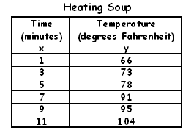

1. Label the graph and plot the points above (using quadrant 1 only)

2. Draw a line of best fit on graph above

3. Pick 2 points on your line ______________________________

4. Slope = ___________________________

5. Equation = ____________________________

6. According to your equation, what would the temperature
be if you cooked it for 19 minutes. ________

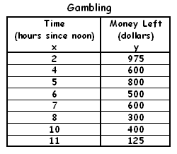
Here is some data on gambling.

7. Label the graph and plot the points above (using quadrant 1 only)

8. Draw a line of best fit above on graph

9. Pick 2 points on your line ________________________

10. Slope = ___________________________

11. Equation = ____________________________

12. According to your equation, how much money would the gambler have left after
5.5 hours ? ________

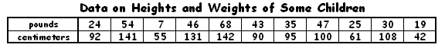
.

14. Graph the data and draw a line of best fit.

15. Choose two points on your line of best fit and list them below.

_______________________________________

16. Write equation of the line ___________________________

17. y intercept ? ______________________

18. Use your equation to predict how tall a child is in centimeters if she weighs 100 pounds.

Money in checking account
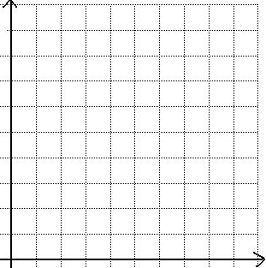
Day Money
0 | 300
1 | 270
3 | 200
4 | 170
5 | 145
7 | 80
8 | 40
9 | 0

19 . Plot points on graph (x axis days – y axis Money in bank account (go by 50)).

20. Draw line of best fit on graph above.

21. List 2 points on your line ________________________________

22. Equation ____________________________

22. Using your equation how much will be in the bank account after 2 days ? _______________

