System of Equations Test
Name ____________________________________

Solve System and Graph (circle answer – graph both lines)

1. -3x + y = 1
y = 3x + 1

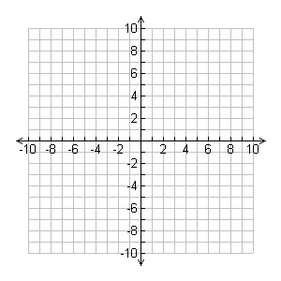

2. -3x + 4y = -5
-4x – 4y = -16

3. -2x – 5y = -10
3x + 4y = 1

4. -5x – 3y = -8
-3x – 5y = -8

5. 4x – y = -4
-5x + 4y = 16

6. -2x – 3y = -2
x = 2y + 8

7. -3x + 3y = 9
x = -4y + 7

