Making the Case for π/4
Jack Nilan
Bridgeport Central High School

When we start out studying circles we begin by studying π. The area of a circle is πr² and the circumference of the circle is 2πr (or πd). How to find the circumference is pretty easy to explain. The circumference is a little more than 3 times as long as the diameter. It makes sense, it is logical and it is pretty easy to understand.
Explaining how to find the area of a circle is harder. I think it mostly taught by telling the students they have to memorize the formula. It can be explained by saying that r² is the area of ¼ of the square that circumscribes it.

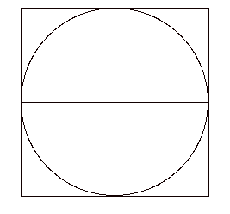 | 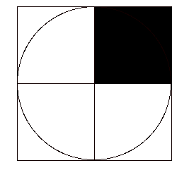
If we say that the area of the circle is equal of a little over 3 (or π) of those squares I think a student can conceptualize why πr² works.
However, I think a case can be made for teaching these concepts differently. I think we need to throw out the old formulas and introduce the concept of π/4. Using the π/4 approach we can say the area and the circumference of the circle are related to the area and perimeter of the square that surrounds it. For example if we have a diameter of 5 for our circle the area of that circle will be π/4 of 25, the area of the square. The circumference of the circle will be π/4 of 20, the perimeter of the square around it.
In the same way we teach the area of a triangle by making a rectangle out of it and then taking half of that for the area, I think a case can be made for solving circles by drawing a square around it and taking π/4 of the easily understood square results.
I think we need to replace πr² and πd with π/4 of the area of the square around the circle and π/4 of the perimeter of the square around the circle. It is easy to understand and easy to remember. The formulas, A = π/4 (d²) and C = π/4 (4d), are there for us if we need them but I don’t think students will need to memorize them once they understand the concept of π/4.

