1. Use the following to answer each question independently. (Answer each question to the original tree)
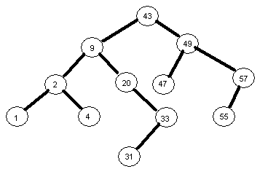
- Show what the tree would look like after adding node 3
- Show what the tree would look like after adding node 90
- Show what the tree would look like after adding node 56
- Show what the tree would look like after deleting node 20
- Show what the tree would look like after deleting node 43
- Show what the tree would look like after deleting node 55
- What are the ancestors of node 33?
- What are the descendants of node 20?
- What would be printed by a postorder traversal?
- What would be printed by a preorder traversal?
- What would be printed by a inorder traversal?
- What is the maximum possible number of nodes in the tree at the level of node 55?
- What is the maximum possible number of nodes in the tree at the level of node 31?
- How many nodes would be in the tree if it were completely full down to the level of node 31?

2. The information field of nodes of a binary tree contains three-letter words. Show how the tree will look after the following words are read (in this order). Assume the tree is empty before you begin adding nodes.

fox dog leg hoe egg elf boy box zoo

3. How would a binary tree look if the information were already ordered when it was read in?

4. A Binary Tree contains Integer values in the value field of each node. Write a function, sumSqrs, that returns the sum of the squares of all the values in the tree.
public int sumSqrs(TreeNode root)

4. A binary search tree contains information about the senior class. It is ordered by GPA. You want to print a listing of the GPAs from highest to lowest, in order to show class standing. Write a procedure to print the student information. (Do not re-order the values in the tree).

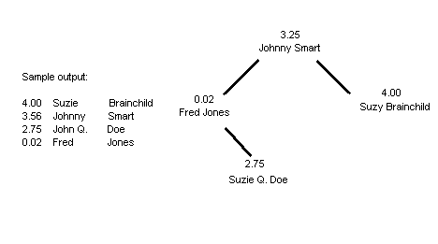

5. The Binary Search Tree is ordered according to the student number. Print the names of all the women, ordered from smallest to largest student number. (recursive). Assume the Objects stored in the BST have a isFemale() method.

6. Write a non recursive procedure, ANCESTOR, that prints the ancestors of a given node whose value field contains a value NUM. NUM only occurs once in the Binary Search Tree. Do NOT PRINT NUM. You may assume that NUM is in (a non-empty) BST. Use the following procedure heading:

public void ancestor(TreeNode root, Integer num)
{ //your code here

}

7. Write a recursive procedure, ANCESTOR. Use the following heading:
public void ancestor(TreeNode root, Integer num)
{ //your code here

}

